HRD MANUAL
Case 1 : If employee has employee id and password, then he/she may login from login form as shown below
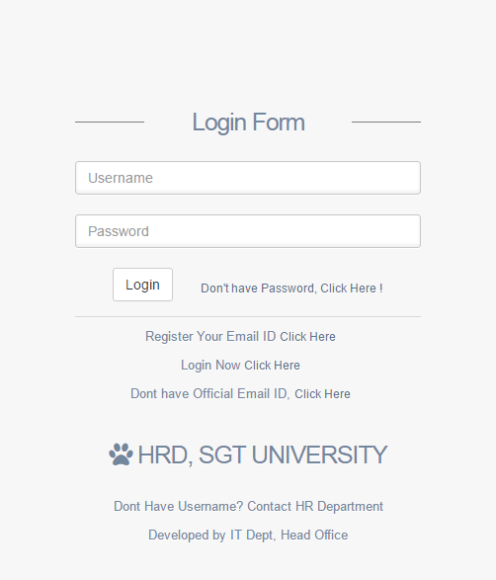

Case 2 : If Employee has Employee ID but don’t have password or employee forget password, then he/she can get his password. Employee must have registered his/her official email id in HR system then only he will receive password on his email account. User has to login HR system : http://sgtuhrd.org -> Click on Don’t have password link -> Fill Your employee id and email id and click on Get Password.

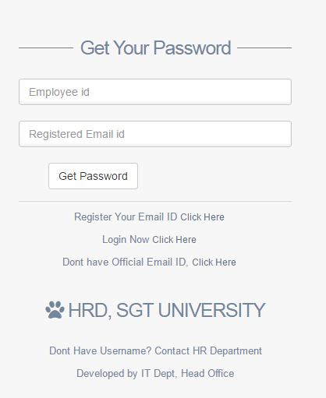

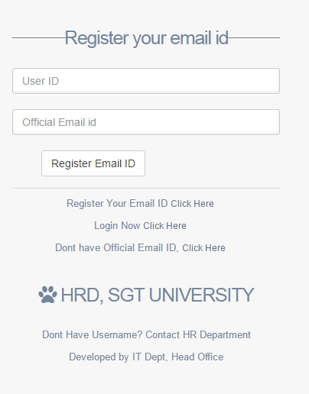Case 3 : If employee did not register his official email ID, he/she can register his/her email by
following steps –
- http://sgtuhrd.org
- Click on Register your email id link
- Fill details in below screen

Case 4 : If employee don’t have official email id, he/she may send request for official email id.
- http://sgtuhrd.org
- Click on Don’t have Official Emial Id - Click here link
- Fill details in below screen
